**JI HYE YUN**

8, Majeon-ro 99beon-gil,

Seo-gu, Incheon, SEOUL 404-820

Rep. of KOREA 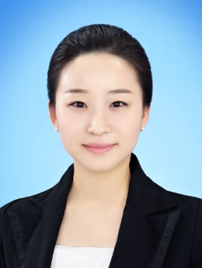

Phone : 010.9504.8212

Email : jhjhy0313@naver.com

13/03/1987 (26years) at Gimpo, (Korea).

**Objective** To obtain an assistant manager

|  |  |
| --- | --- |
| **Education** | |
| 2007 - 2013 | University of Incheon – European Commerce and French Literature (double courses) |
| 2009-2010 | Exchange student at University of Avignon (France) |
| **Experience** | |
| May 2012 – Dec 2013 | Teacher of Creative Literature by Korea Arts & Education Service  -Planning and Teaching educational programs for young people  -Collaboration with regional Library and Local Children’s center for creative literature exhibition  -Marketing educational Activity  -Editing and publishing books « Students Works » |
| May 2012 – Dec 2012 | KBBY(National section of Korea, The International Board on Books for Young people)  -Accounting & Administration |
| April 2011 – Sept 2012 | Assistant  « Youth Leader Camp » by Youth Career center  -Planning a camp for students about good career  -Assisting in PR and Organaizing an event for helping an employ |
| July 2010 - January 2012 | Part Time job  -Translation at IL-KWANG company (French - Korean)  -Interpreting an « Avignon Theater Festival » |
| **Relevant Skills & Courses** | |
| Langues | English : Intermediate level  French : Intermediate level |
| Computer | Good for using Microsoft Office and operating computer |
| **Activities** | |
|  | -Assistant NAVER BLOG « la vie de rêve »  -Volunteer in France at International Work Camp Organizations, summer 2010  -Trip : UK, France, Italy, Spain etc. 8 countries in Europe |
| **Awards** | |
| November 2012 | Won a Silver medal « PARKER Essay Contest » by PARKER company |
| 2nd semester 2011 | Won an award «Student Paper competition» by University of Incheon |
| July 2010 | Won an award «Excellence Cultural Activity team» |
| 2007-2013 | Won the 5 Times scholarships in Uvinversity of Incheon |